Crean ate IBM Cloud Account

|  |  |
| --- | --- |
| Team ID | PNT2022TMID06323 |
| Project Name | AI-Powered Nutrition Analyzer for Fitness  Enthusiasts |
| Batch No | B3-3M5E |

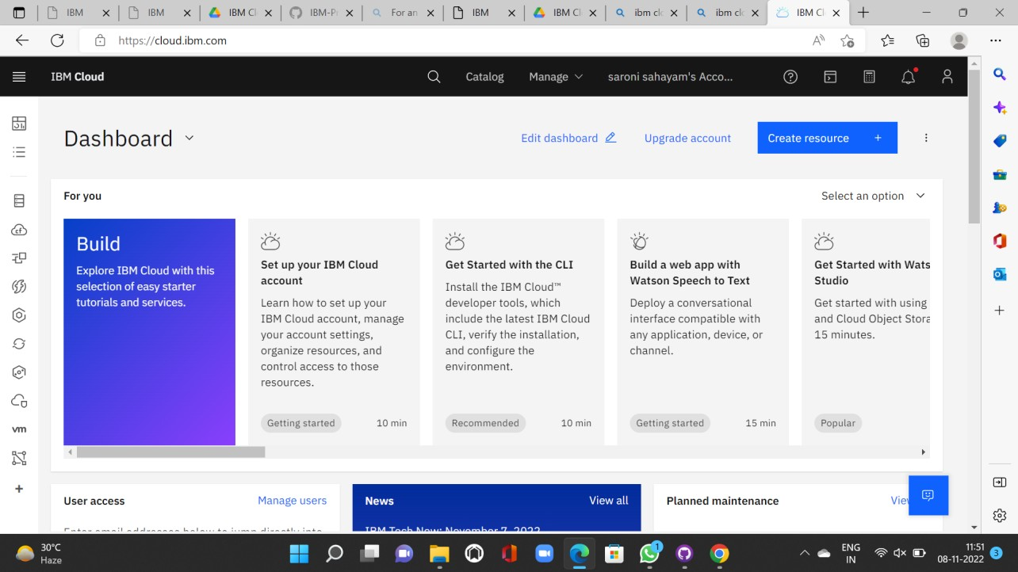

Subashri.S

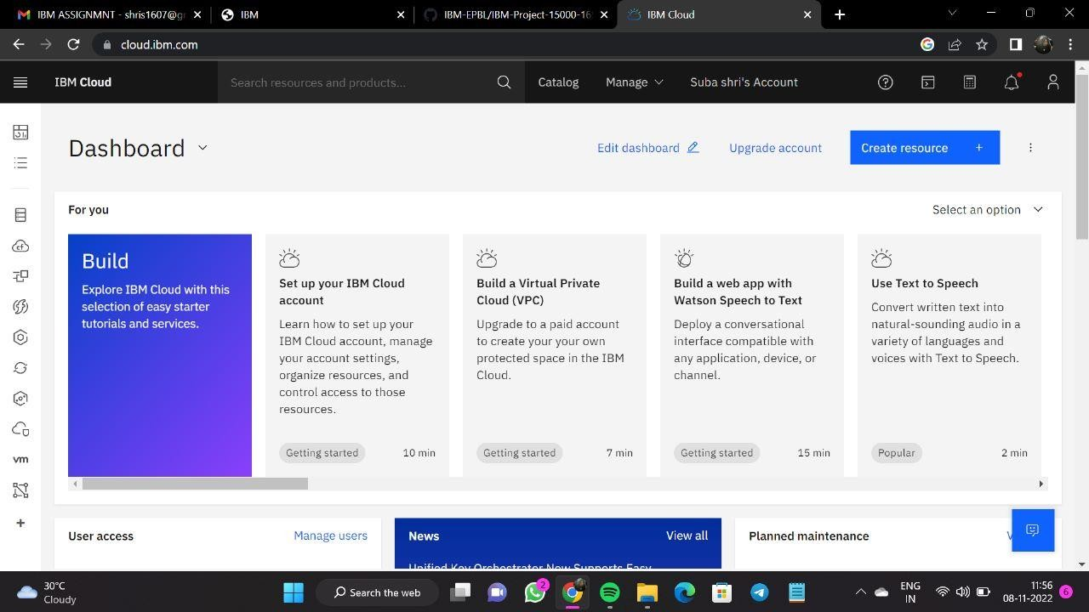

Subhashini.R

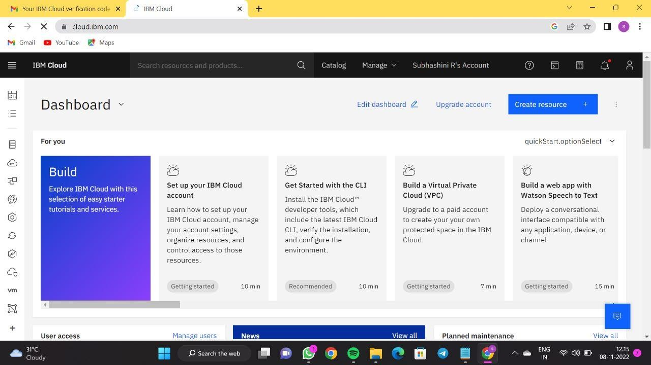

Sriharini.K

